Zepp E User Guide
Contents
Getting Started 3
Appearance 3
Turning On and Off 3
Charging 4
Wearing and Replacing the Strap 4
Connection and Pairing 5
Watch System Update 6
Control Center 6
Time Format 6
Unit Conversion 6
Common Operations 6
Features Available When Connected to a Mobile Phone 8
Reception of Notifications from the Phone 8
Receiving Incoming Call Alerts from the Phone 9
Controlling the Phone's Music Player 9
Find My Phone 10
Find Watch 10
Watch Face 11
Watch Face Widgets 11
Always On Display 12
Adding a Watch Face 12
Changing the Watch Face 13
Deleting a Watch Face 13
Feature Shortcuts 13
Quick Access Apps 13
Long Pressing the Side Button 13
Workout 14
Workout 14
Outdoor Workouts Using the Phone's GPS 14
Workout Reminders and Settings 15
Workout Control 16
Viewing Workout Records 17
Activity and Health 18
PAI 18
Activity Goal 19
Idle Alert 19
Heart Rate 20
Heart Rate Alert 20
Automatic Heart Rate Detection 20
Manual Measurement 21
Heart Rate Measurement Precautions 21
Sleep 21
Sleep Assistant 21
SpO2 22
SpO2 Measurement Precautions 22
Watch Apps 23
App List 23
Schedule 24
Weather 25
Compass 25
Alarm 26
Timer 26
Countdown 27

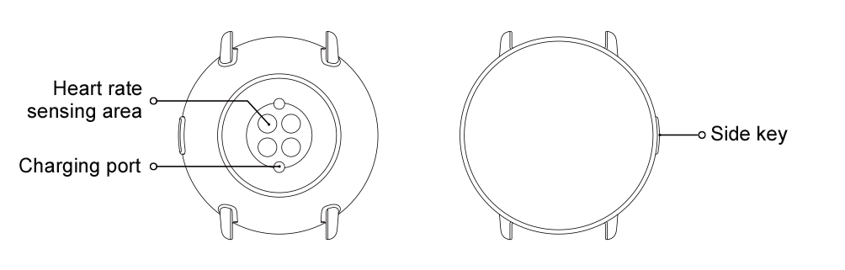
Getting Started

Appearance

Turning On and Off
Turning on:
Press and hold the side button of the watch until the screen lights up and the startup screen appears. If turning on the watch by long pressing the side button does not work, charge the watch and retry.
Turning off:
Press and hold the side button of the watch for 5 seconds to go to the power off menu, and then choose whether to turn off or reboot the watch.
Forced shut-off:
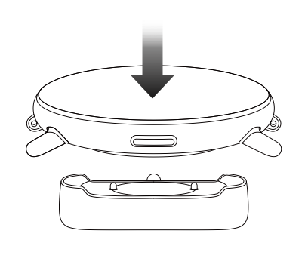
Press and hold the side button of the watch for 10 seconds to turn off the watch.

Charging
This product is charged using a magnetic charging base. Please use the standard charging base for charging. Align the charging port with the metal contacts on the charging base until the charging level indicator appears on the watch screen.
Note:
Use the original charging base and ensure that the charging port is dry.
Connect the USB port to a computer USB port or a mobile phone charger with an output current above 1A.

Wearing and Replacing the Strap
Wear the strap at a comfortable tightness to allow the skin to breathe and the sensor to function.
When measuring SpO2 (blood oxygen saturation), avoid wearing the watch on the wrist joint, keep your arm flat, maintain a comfortable (appropriately loose) distance between the watch and the wrist skin, and keep your arm still throughout the measurement process. When affected by external factors (such as arm sag, arm sway, arm hair, and tattoos), the measurement result may be inaccurate or the measurement may fail and provide no output.
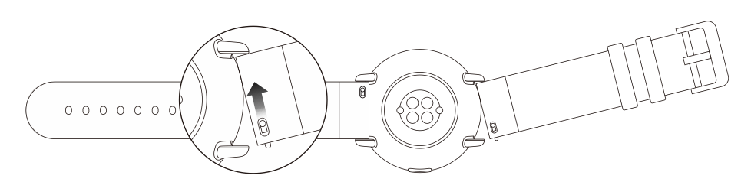
You can tighten the watch strap during workouts and loosen it afterwards. Tighten the strap appropriately if your watch sways on your wrist or produces no data output.
To attach or detach the watch strap, see the illustration below.
Note:
Once the strap is attached, pull on the strap with appropriate force to ensure secure attachment.
Avoid contact with liquid, because the leather strap is not waterproof. Switch to a fluororubber or silica gel strap when you cannot avoid contact with liquid, for example when swimming.

Connection and Pairing
Scan the following QR code with a mobile phone to download and install the Zepp app. To improve your experience, update the app to the latest version as prompted.
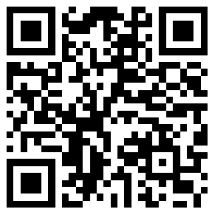
Note: The mobile phone's system must be Android 5.0 (or later) or iOS 10.0 (or later).

Initial pairing:
When you turn on the watch for the first time, the screen displays the QR code used for binding.
Log in to the Zepp app on your phone and scan the QR code displayed on the watch screen as prompted.
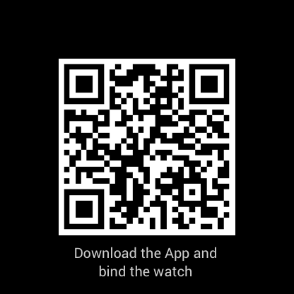
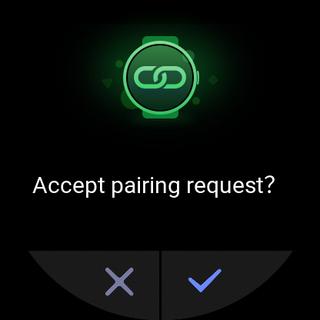
Pairing the watch with a new phone:
- Open the Zepp app on the old phone and synchronize data to the watch.
- On the old phone, choose Profile > My Device > Zepp E, swipe down to the bottom, and tap Unpair to unbind the watch.
- Reset and reboot the watch. Then, pair the watch with the new phone in the same manner as the initial pairing process.

Watch System Update
Keep the watch connected to the phone, open the Zepp app, and choose Profile > My Device > Zepp E > Check for updates to check or update the watch system.
We recommend that you tap Update Now once your watch receives the system update push.

Control Center
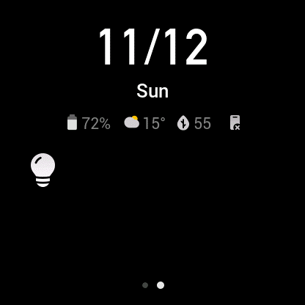
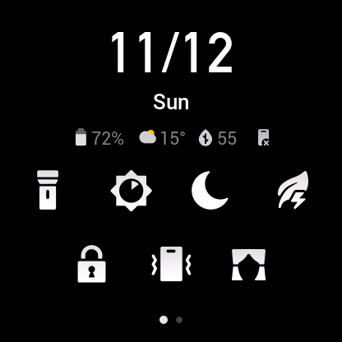
Swipe down on the watch face to go to the control center to use the system features, such as the flashlight, screen brightness adjustment, do-not-disturb mode, power saving mode, screen lock, find my phone, theater mode, and screen always on.

Time Format
Keep the watch connected to the phone. During the data synchronization process, the watch automatically uses the phone's system time and time format, which may be the 12- or 24-hour format.

Unit Conversion
Keep the watch connected to the phone. Open the Zepp app and choose Profile > More > Settings to set the units for distance and weight. The watch automatically uses the phone's unit during the data synchronization process.

Common Operations
Tap on the screen | To use the current feature, select the current item, or go to the next step.
Tap and hold the watch face | To activate watch face options and settings.
Cover the screen | To turn off the screen.
Swipe up/down and left/right on the screen | To scroll or switch the current screen. You can swipe right on certain screens to return to the previous screen.
Press the side button | To wake the watch, go to the app list, or return to the watch face.
Press and hold the side button for 1 second. | To quick-start a specified app.
Press and hold the side button for more than 5 seconds. | To turn on the watch, go to the reboot screen, or turn off the watch.

Features Available When Connected to a Mobile Phone

Reception of Notifications from the Phone
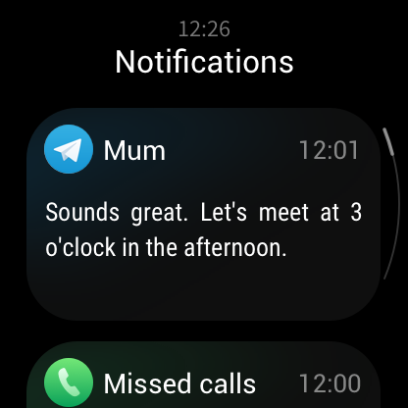
After you connect the watch to the phone, the watch can receive notifications from the phone. Swipe up on the watch face to go to the notification center, where you can view the latest 20 notifications.
How to configure:
Keep the watch connected to the phone. Open the Zepp app, choose Profile > My Device > Zepp E > App alerts, and then select the apps for which you want to receive notifications.
Note:
To use this feature in the Android system, add the Zepp app to the phone's background whitelist or auto-start list to keep the Zepp app always running in the background. If the background process is cleared by the phone, the watch is disconnected from the Zepp app, making it unable to receive app notifications.

Receiving Incoming Call Alerts from the Phone
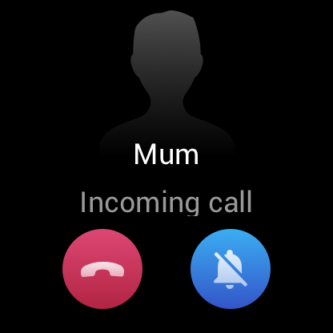
After you connect the watch to the phone, you can use the watch to receive incoming call alerts from the phone, and choose to answer the calls on the phone or ignore the calls on the watch.
How to configure in the Android system:
Keep the watch connected to the phone. Open the Zepp app, choose Profile > My Device > Zepp E > Incoming call > Incoming call alerts, and tap the "Go to Settings" prompt on the top. When the dialog box for call permission authorization appears, grant call permissions to the Zepp app. If the prompt does not appear, call permissions have been granted to the Zepp app.
Note:
To use this feature in the Android system, add the Zepp app to the phone's background whitelist or auto-start list to keep the Zepp app always running in the background. If the background process is cleared by the phone, the watch is disconnected from the Zepp app, making it unable to receive incoming call alerts.

Controlling the Phone's Music Player
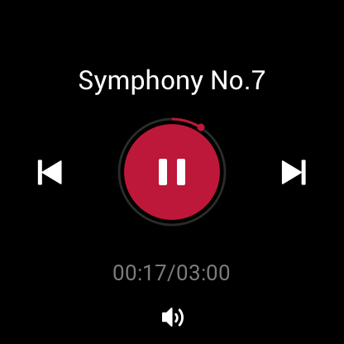
Keep the watch connected to the phone. When the phone is playing music, you can use the watch's music app to control the phone's music player. For example, you can pause the song being played, adjust the volume, or switch to the previous or next song.
How to configure in the Android system:
Keep the watch connected to the phone. Open the Zepp app, choose Profile > My Device > Zepp E > App alerts, and tap the "Can't access notifications" prompt on the top. When the screen for notification permission settings appears, grant the notification read permission to the Zepp app. If the prompt does not appear, the notification read permission has already been granted to the Zepp app.
Note:
To use this feature in the Android system, add the Zepp app to the phone's background whitelist or auto-start list to keep the Zepp app always running in the background. If the background process is cleared by the phone, the watch is disconnected from the Zepp app, making it unable to control the phone's music player.

Find My Phone
- Keep the watch connected to the phone.
- Swipe down on the watch face to the control center and tap the phone vibration icon. Then, the phone vibrates and rings.
- In the app list, select Widgets and tap Find Mobile. Then, the phone vibrates and rings.

Find Watch
Keep the watch connected to the phone. Open the Zepp app and choose Profile > My Device > Zepp E > Find Watch. Then, the watch vibrates.

Watch Face

Watch Face Widgets
Some watch faces support watch face widgets, allowing you to view such information as steps, calories, and weather. You can tap a widget to open the corresponding app. You can also edit a watch face widget as needed.
Edit a watch face widget as follows:
- Wake the watch, and tap and hold on the watch face to go to the watch face selection screen.
- Swipe left and right to preview the available watch faces on the watch. The Edit button appears in the lower part of any watch face if it supports widgets. Tap Edit to go to the widget edit screen.
- Select the widget you want to edit, and tap the widget or swipe up and down on the screen to replace the widget.
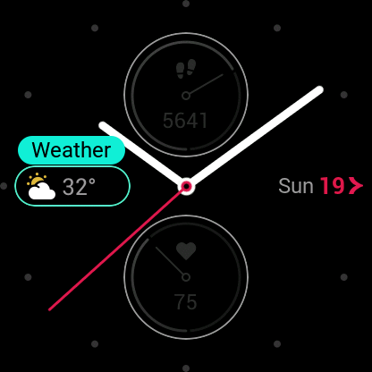
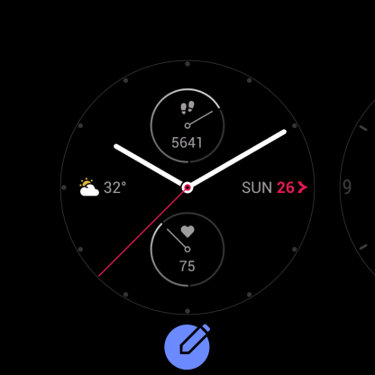
- After you finish editing, press the side button to apply the new watch face.

Always On Display
After this feature is enabled, the watch in the standby state still displays some information on the watch face instead of completely turning off the screen. This seriously reduces the battery life.
Set the Always On Display as follows:
- After you wake the watch, press the side button on the watch face to go to the app list, and choose Settings > Always On Display.
- Select a watch face style and enable or disable Always On Display.
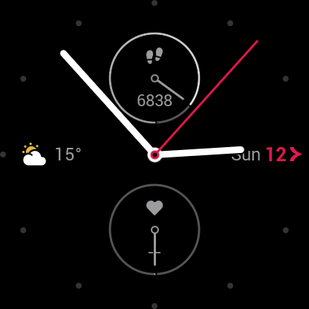

Adding a Watch Face
The watch provides a few built-in watch faces. You can also synchronize online watch faces from the Zepp app's Watch Face Mall to the watch, or use the Zepp app to set an image on your phone as a custom watch face.
Add an online watch face as follows:
- Keep the watch connected to the phone. Open the Zepp app and choose Profile > My Device > Zepp E > Watch Face Mall.
- Select and synchronize one or more watch faces to the watch. Then, you can switch between different watch faces on the watch.
Add a custom background watch face as follows:
Keep the watch connected to the phone. Open the Zepp app, choose Profile > My Device > Zepp E > Watch Face Mall, and switch to a custom background watch face.

Changing the Watch Face
- Wake the watch, and then tap and hold on the watch face to go to the watch face selection screen.
- Swipe left and right to preview the available watch faces on the watch, including the built-in watch faces, synchronized online watch faces, and custom watch faces.
- Tap the desired watch face to apply it.

Deleting a Watch Face
When the number of watch faces synchronized to the watch reaches the storage limit, you will need to delete some watch faces before you can add more. The built-in watch faces cannot be deleted.
- Wake the watch, and then tap and hold on the watch face to go to the watch face selection screen.
- Swipe left and right to preview the available watch faces on the watch, including the built-in watch faces, synchronized online watch faces, and custom watch faces.
- Find the watch face you want to delete and swipe up on the screen. The Delete button will appear if this watch face can be deleted. Then, tap Delete to delete the watch face.

Feature Shortcuts

Quick Access Apps
The watch face displays quick access apps on the left and right. You can also add frequently used apps and features, such as workouts, to the short access apps.
Change the quick access apps as follows:
- After you wake the watch, press the side button on the watch face to go to the app list, and then choose Settings > Quick Access Apps. Swipe up and down on the screen to view the apps that can be added to the quick access apps.
- When apps in the Current Apps section reach the maximum number, no more apps can be added to the quick access apps. When this happens, remove some apps from Current Apps.

Long Pressing the Side Button
On the watch face, press and hold the side button for 1 second to quickly open an app. The workout app is opened by default. You can go to the Settings screen to set a frequently used app as the app to be opened by default.

Workout

Workout
The watch provides 11 workout modes: Outdoor Running, Walking, Outdoor Cycling, Treadmill, Indoor Cycling, Pool Swimming, Elliptical Trainer, Climbing, Trail Running, Skiing, and Freestyle.

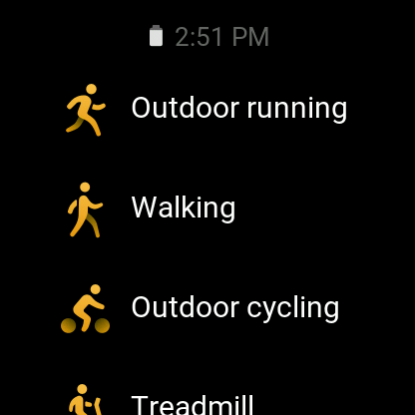
After you wake the watch, press the side button on the watch face to go to the app list and tap Workout. Tap the desired workout mode and tap GO on the workout preparation screen to start recording your workout data.

Outdoor Workouts Using the Phone's GPS
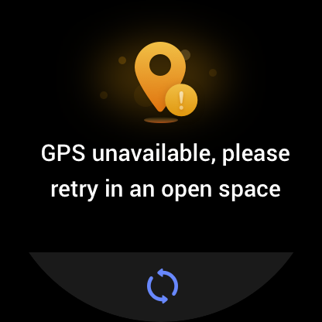
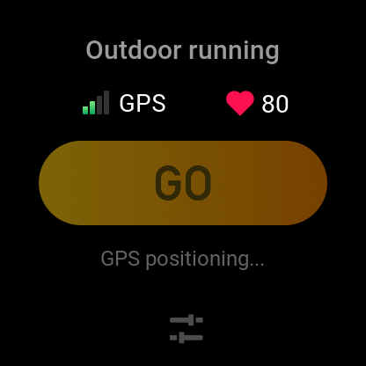
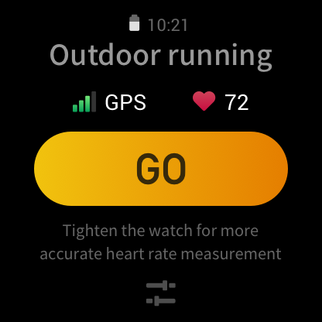
We recommend that you use your phone's GPS during outdoor workouts to record more accurate data. To do this, you need to keep the watch connected to the phone throughout the entire workout.

Apply the phone's GPS to the watch as follows:
- Go to the phone's system permissions screen and authorize the Zepp app to read GPS data.
- Keep the phone's GPS and Bluetooth on throughout your workout. For the Android system, keep the Zepp app running in the background.
- If the watch is connected to the phone's GPS during your workout, it automatically starts positioning and searching. Otherwise, connect the watch to the phone's GPS as prompted.
- Use GPS positioning in open outdoor areas, and wait until the positioning is successful before you start your workout.

Workout Reminders and Settings
On the workout preparation screen, tap the workout setting icon to set the current workout mode. The settings vary depending on different workout modes.
Workout goals:
You can set a goal reached reminder for the expected distance, duration, and calories.
Workout reminders:
You can set reminders for distance, safe heart rate, heart rate zone, and pace.
Auto pause:
The watch automatically detects your workout status. When you stop your workout, it automatically stops recording workout data. When you start your workout again, it resumes workout recording.
Real-time graph:
You can set the real-time graph to display your heart rate, pace, speed, and pull speed rate during workout.
Swimming lane length:
During pool swimming, set the swimming lane length to record your swimming distance.

Workout Control
Keep the workout app running in the background as follows:
- If you want to use other features during your workout, press the side button to return to the watch face and select the desired feature. This leaves the workout app running in the background.
- While running in the background, the workout app still records your workout data and gives reminders based on workout settings.
- When you open the workout app again, it automatically enters the current workout mode.
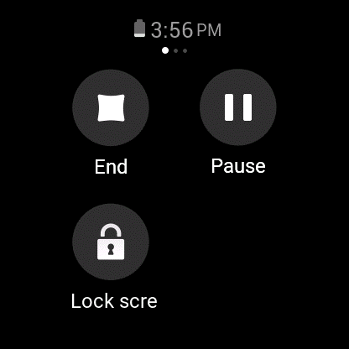
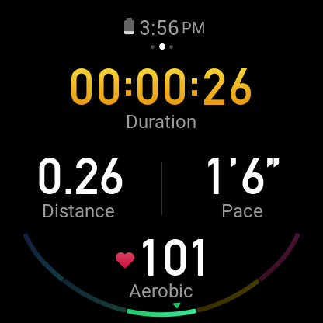
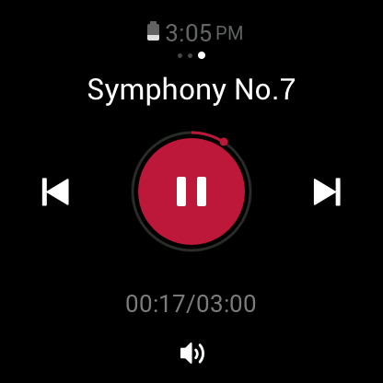
Control the phone's music player during your workout as follows:
During your workout, swipe left on the data screen to quickly access the phone's music player. For more information, see the "Controlling the Phone's Music Player" section in the FAQ manual.
Check data during the workout as follows:
During your workout, swipe up and down on the data screen to view different data records.
Control a workout in progress as follows:
During your workout, swipe right on the data screen to suspend, continue, or end workout, or lock the screen.
Save workout data as follows:
When the workout ends, if the actual distance or duration is less than the set value, the workout is not recorded. Due to limited storage, we recommend that you promptly synchronize workout data to the app after workout to prevent it from being overwritten.

Viewing Workout Records
View workout records on the watch as follows:
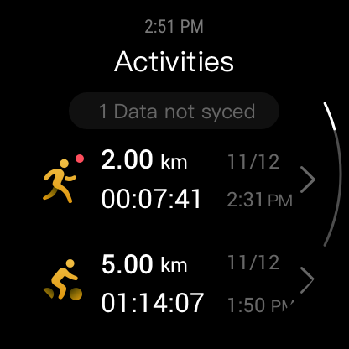
After you wake the watch, press the side button on the watch face to go to the app list and tap Activities to view the latest 30 workout records. Select to view the details of each record.

View workout records on the phone as follows:
After workout data is synchronized to the app, you can view the data on the Exercise record screen of the phone.

Activity and Health

PAI
PAI is a personal physiological activity indicator. Heart rate data, daily activity intensity, and physiological data are evaluated in a multi-dimensional, dynamic, and comprehensive manner to obtain an intuitive PAI value using an algorithm. PAI helps you understand your physical condition without relying on any single data record.
You can obtain your PAI value by maintaining a certain intensity of daily activities or workouts. According to the HUNT Fitness Study* research results, keeping your PAI value above 100 reduces the risk of death from cardiovascular disease and increases life expectancy.
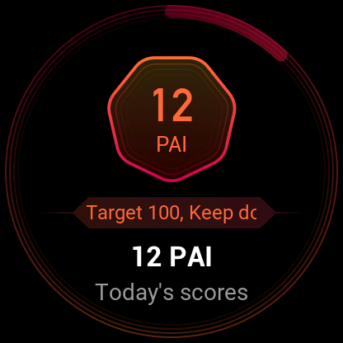
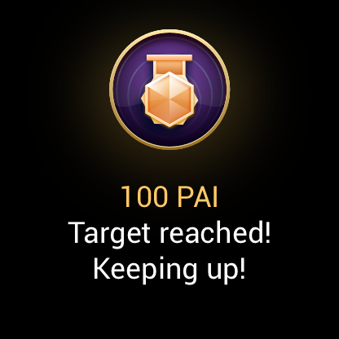
To learn more, open the Zepp app and choose PAI > PAI FAQs.
* HUNT Fitness Study: This study was a subproject of the HUNT study, and was led by Professor Ulrik Wisloff from the Medical School of Norwegian University of Science and Technology. The HUNT study lasted over 35 years and involved more than 230,000 participants.

Activity Goal
The watch automatically records your activity data, including steps, calorie consumption, stand-up times, and running or walking distance. It calculates your fat-burning minutes based on heart rate data.
- The daily activity goal consists of three bands: activity band (you can select Steps or Calories as the goal), fat-burning band, and stand-up band.
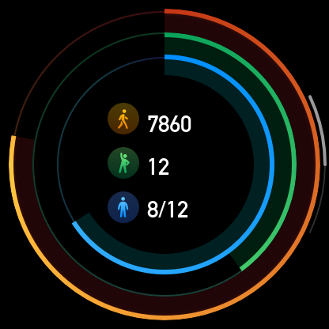
- The watch vibrates after you complete a band.

Idle Alert
While you are wearing the watch in the wakeup state, it monitors your activity status and prompts you to exercise every hour.
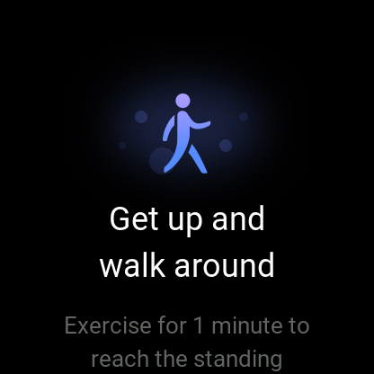
If you have not exercised for more than 1 minute after 50 minutes of the current hour have elapsed, the watch vibrates to prompt you to exercise. After receiving an idle alert, you can exercise before the next hour arrives to complete the standing band of the current hour.Enable the idle alert feature as follows: Keep the watch connected to the phone. Open the Zepp app and choose Profile > My Device > Zepp E > Idle Alert and enable this feature.

Heart Rate
Heart rate is an important health indicator.
More frequent heart rate measurement helps you detect more heart rate changes and helps you create a healthy lifestyle.

Heart Rate Alert
You can enable the heart rate alert feature when you set the detection interval as within 10 minutes.
The watch vibrates when the measured heart rate is greater than the set value and no activity has been detected from you for the past 10 minutes.

Automatic Heart Rate Detection
- Keep the watch connected to the phone. Open the Zepp app and choose Profile > My Device > Zepp E > Heart Rate Detection to enable automatic heart rate detection and set the detection frequency. Then, the watch periodically measures your heart rate at the set frequency throughout the day and records heart rate changes.
- You can enable activity detection as your heart rate changes more frequently when you are exercising. This allows the watch to automatically increase the detection frequency when it detects that you are exercising to record more changes in your heart rate.
- Open the heart rate app of the watch to view your heart rate curve and heart rate zone distribution on the current day.

Manual Measurement
- If automatic heart rate detection is not enabled, after you wake the watch, press the side button on the watch face to go to the app list, and swipe up and down on the screen to select the heart rate app to enable manual heart rate measurement.
- Add the heart rate app to the quick access apps to more conveniently measure your heart rate.
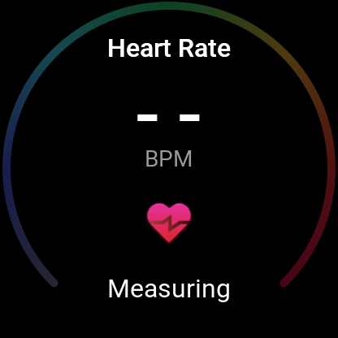
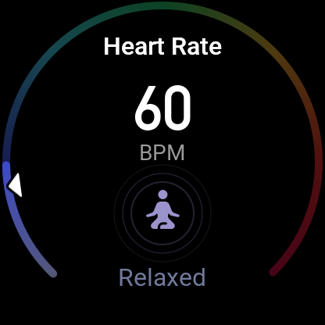
- The watch only provides the heart rate that is measured at the present time. To view historical records, synchronize data to the app.

Heart Rate Measurement Precautions
To ensure the accuracy of heart rate measurement, wear the watch correctly, and ensure that the portion in contact with your skin is clean and free of sunscreen smear.

Sleep
Sleep quality is closely related to health.
When you wear the watch during sleep, it automatically records your sleep quality. You can synchronize records to the app to view your sleep duration, sleep stages, and sleep score, as well as receive suggestions to improve sleep.

Sleep Assistant
Keep the watch connected to the phone. Open the Zepp app, choose Profile > My Device > Zepp E > Heart Rate Detection > Detection Method, and turn on Sleep Assistant. This allows you to obtain more accurate information about your sleep quality (during the REM sleep stage).

SpO2
SpO2 is an important physiological parameter of the respiratory cycle.
- After you wake the watch, press the side button on the watch face to go to the app list, and select the SpO2 app to start manual SpO2 measurement.
- Add the SpO2 app to the quick access apps to measure your SpO2 more conveniently.
- When climbing, you can set the workout app to run in the background and start the SpO2 app for measurement.
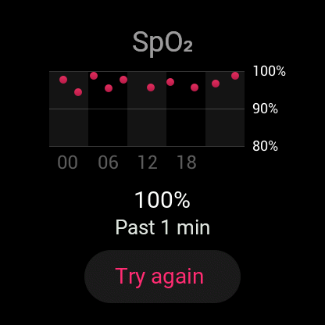
- Once measurement is complete, the watch displays the measurement result. You can also view the all-day measurement results.

SpO2 Measurement Precautions
- Wear the watch a distance of one finger away from the carpal (ulnar).
- Wear the watch at an appropriate tightness.
- Place your arm on a stable surface such as a tabletop for measurement, with the watch screen facing up.
- Remain still during measurement and stay focused during the process.
- When affected by external factors (such as arm hair, tattoos, arm sway, low temperature, and incorrectly wearing the watch), the measurement result may be inaccurate or measurement may fail and produce no output.
- The measurement range is 80% to 100%, This feature is for reference only and should not be used as a basis for medical diagnosis. If you feel unwell, please consult a medical institution.

Watch Apps
The watch provides a series of apps that can be used independently, such as workout, heart rate, and weather.
You can open an app using either of the following two methods:
- After you wake the watch, press the side button on the watch face to go to the app list, swipe up and down on the screen to browse the app list, and then tap the desired app.
- Add frequently used apps to the quick access apps to access them more conveniently. For more information, see the "Quick Access Apps" section.

App List
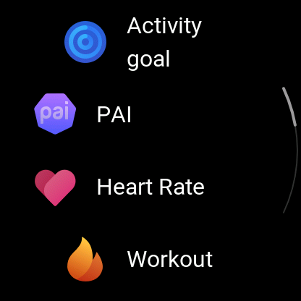
Keep the watch connected to the phone. Open the Zepp app and choose Profile > My Device > Zepp E > Watch display settings to set the apps that can be viewed on the watch.

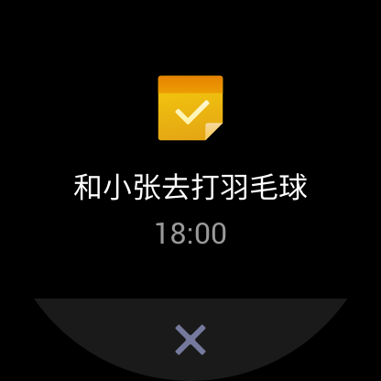
Schedule
Have dinner

After you create a schedule, the watch vibrates to remind you of your schedule on the set day.
Attend a meeting
Check email

Keep the watch connected to the phone. Open the Zepp app and choose Profile > My Device > Zepp E > Schedule to create or edit a schedule.
After you wake the watch, press the side button on the watch face to go to the app list, then tap Schedule to view all set schedules. Select a schedule to edit the date and time of the schedule reminder.

Weather
You can check today's weather, wind, humidity, UV intensity, and other information at any time, as well as the weather information for the current location over the next 7 days.
Weather information can be synchronized only through the mobile phone network, so you need to connect the watch to the phone for real-time weather information updates.
You can set a city and a temperature unit (Celsius or Fahrenheit) in the Zepp app.
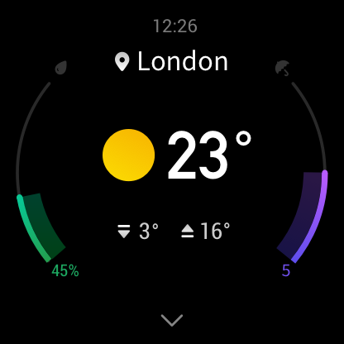

Compass
Before use, you need to calibrate the compass against interference by drawing the number 8 in the air with the watch. The app will display the calibration alert. After calibration is complete, the orientation and angle pointed directly above the watch are displayed.
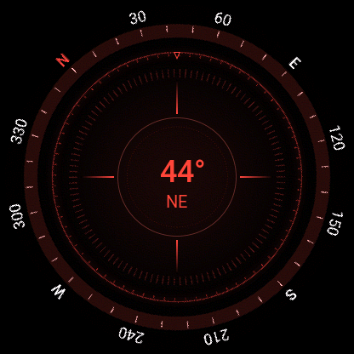
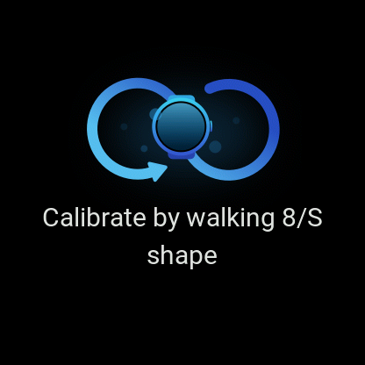
To avoid interference and improve accuracy, keep the watch away from any magnetic field and keep it level when you use the compass.

Alarm
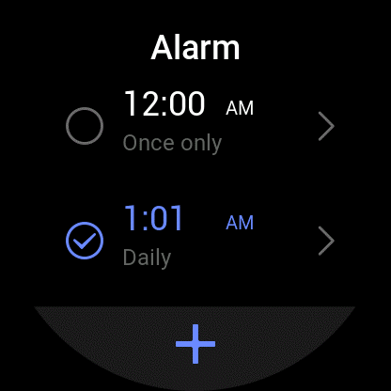
You can add alarms in the Zepp app and on the watch, set repeated alarms, and turn on/off alarms. Tap and hold an alarm to delete it.
The watch vibrates at the set time. You can choose to turn off the alarm or enter the nap mode, which will send you an alarm 10 minutes later. You can use the nap mode for up to five consecutive times.
If no operation is performed after the watch has vibrated for 30 seconds, it automatically enters the nap mode.

Timer
A timer with a 0.01-second precision can record 24 hours at most.
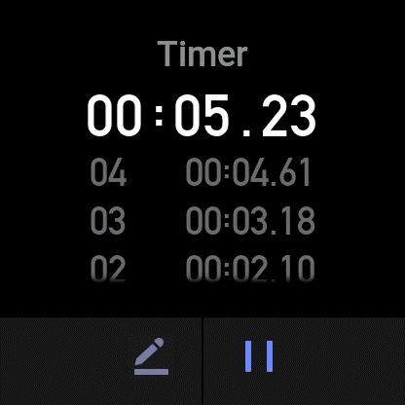
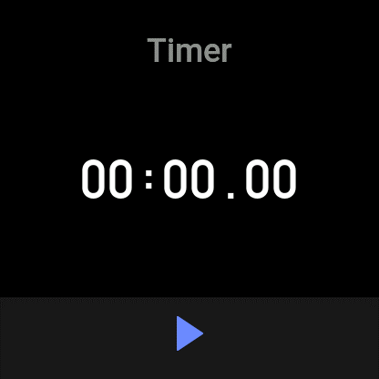
You can count repetitions during the timing process. Up to 99 repetitions can be counted.

Countdown
Once you set a countdown, the watch vibrates after the countdown ends.
